CANTERBURY CRICKET ASSOCIATION 1950/51

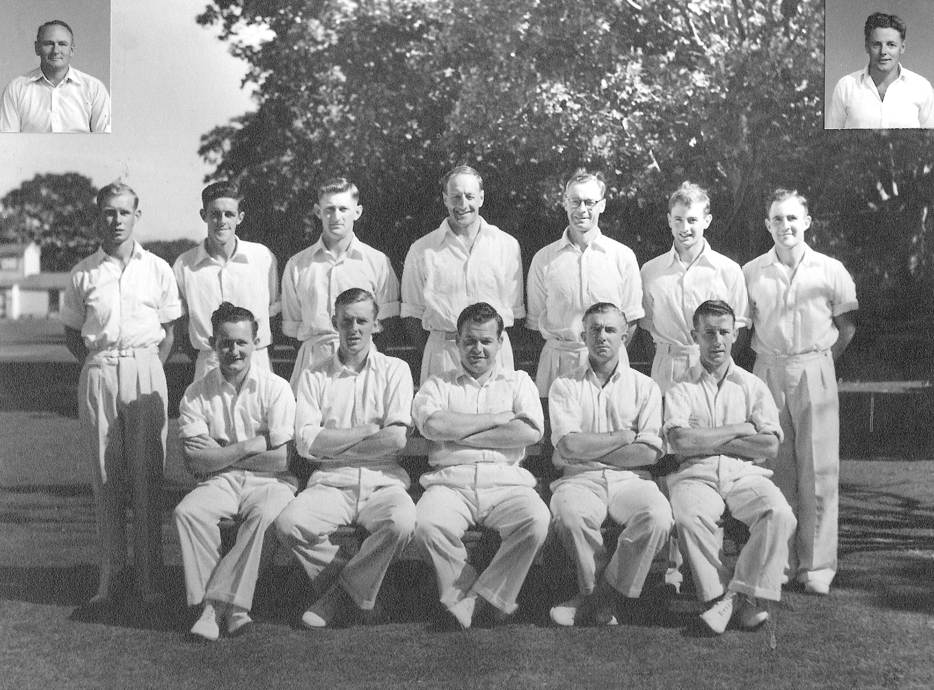

**Back row:** MB Poore, N Bennett, JA Hayes, F Dawson, WA Hadlee, PGZ Harris, JD Alderson

**Front row:** GF Anderson, AR MacGibbon, JG Leggat (captain), RWG Emery, RT Dowker

**Inset:** TB Burtt, AT Burgess